BIOL 31; Human Physiology
Lab 1: Scientific inquiry and graphing (20 points: lab reports)

Part 1: The Scientific Method

Answer the following questions:

- Compare and contrast a hypothesis and a scientific theory?

- Let’s say you work for NASA and have been asked to conduct an experiment for the Laboratory of Human Factors. NASA wants to know if people eat more when their environment is cold compared to when it is warm. You create a hypothesis stating “People eat more when the air temperature is cold than when it is warm.”

- Generally speaking, how would you test this hypothesis? (i.e., design an experiment) (part a. is not graded, just a space for you to organize your thoughts)

- State two operational definitions for this experiment.

- What is the independent variable of your experiment?

- What is the dependent variable of your experiment?

- List a control variable needed for your experiment:

Part 2: Making Graphs

Often times, scientists use graphs to communicate aspects of their data. There are many different types of graphs. A common type is the scatter point graph. You will construct one of these graphs using the following data:

In your physiology lab class you measure the amount of muscle activity in the biceps brachii muscle of three subjects as you systematically increase the weight that each subject had to hold for 10 seconds. Your findings are listed in this table:
Weight (kg) | Muscle Activity (µV)
Weight (kg) | Subject 1 | Subject 2 | Subject 3
0 | 0.2 | 0.1 | 0.1
2.5 | 0.5 | 0.5 | 0.4
5 | 3.4 | 3.9 | 3.4
7.5 | 7.6 | 12.2 | 6.9
10 | 15.1 | 22.2 | 11.3
12.5 | 18.5 | 30.5 | 13.3
13 | 18.4 | 30.3 | 13.2
14 | 18.4 | 30.5 | 0
15 | 18.4 | 31.1 | 0

On the graph paper provided on the next page, make a line graph of these data. Show all 3 subjects on the same set of axes (i.e., same graph).

- In the dataset, which variable is the dependent variable and which one is the independent variable?

Dependent: __________________

Independent: __________________

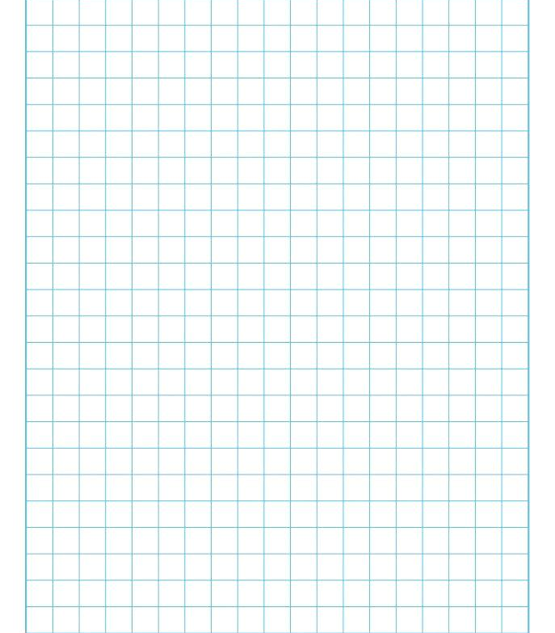
- Which subject had the largest amount of muscle activity?

- Describe the general relationship between the weight being held and the muscle activity of all 3 subjects for weights between 0 and 12.5 kg.

- Describe something you noticed about the muscle activity between 10.0 and 15 kg?
It is important to be able to interpret graphs generated in physiology, so here is another graph for you to practice interpreting.

- The graph below shows the relative amount of several hormones during the course of pregnancy. Study the graph and answer the questions.

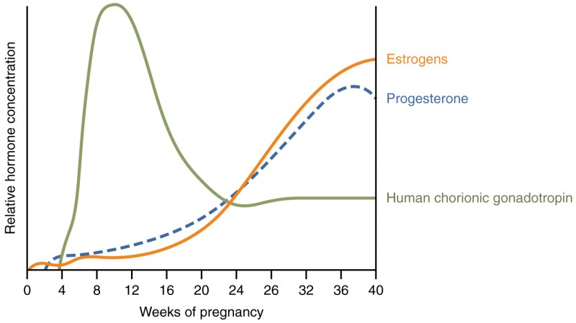

- Can you determine the exact amount of each hormone? Why or why not?

- Describe the trend in relative levels of estrogens from 20-40 weeks.

- Which hormone had the highest level over the course of pregnancy?

- Which hormone had the lowest level at 12 weeks?

- Is there a moment during pregnancy where all of the hormones are found in about the same concentration? If so, at which time point in pregnancy does this equality occur?

- List the dependent and independent variables for this study, based on the graph.

